EXP 3: EXAM REGISTRATION SYSTEM

1.USE CASE DIAGRAM:

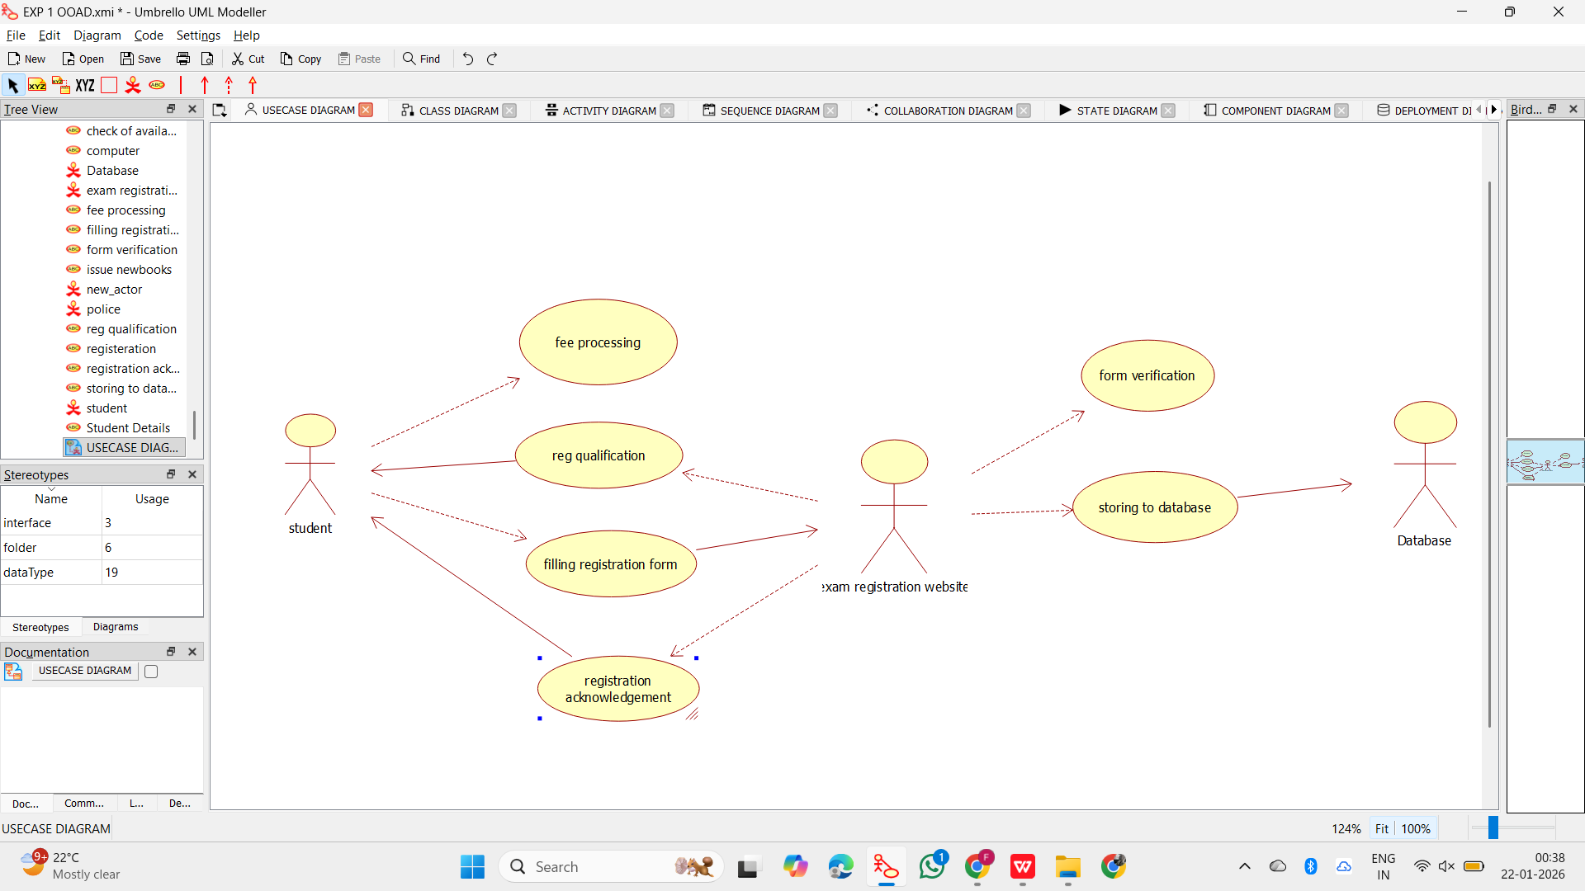

2.CLASS DIAGRAM:
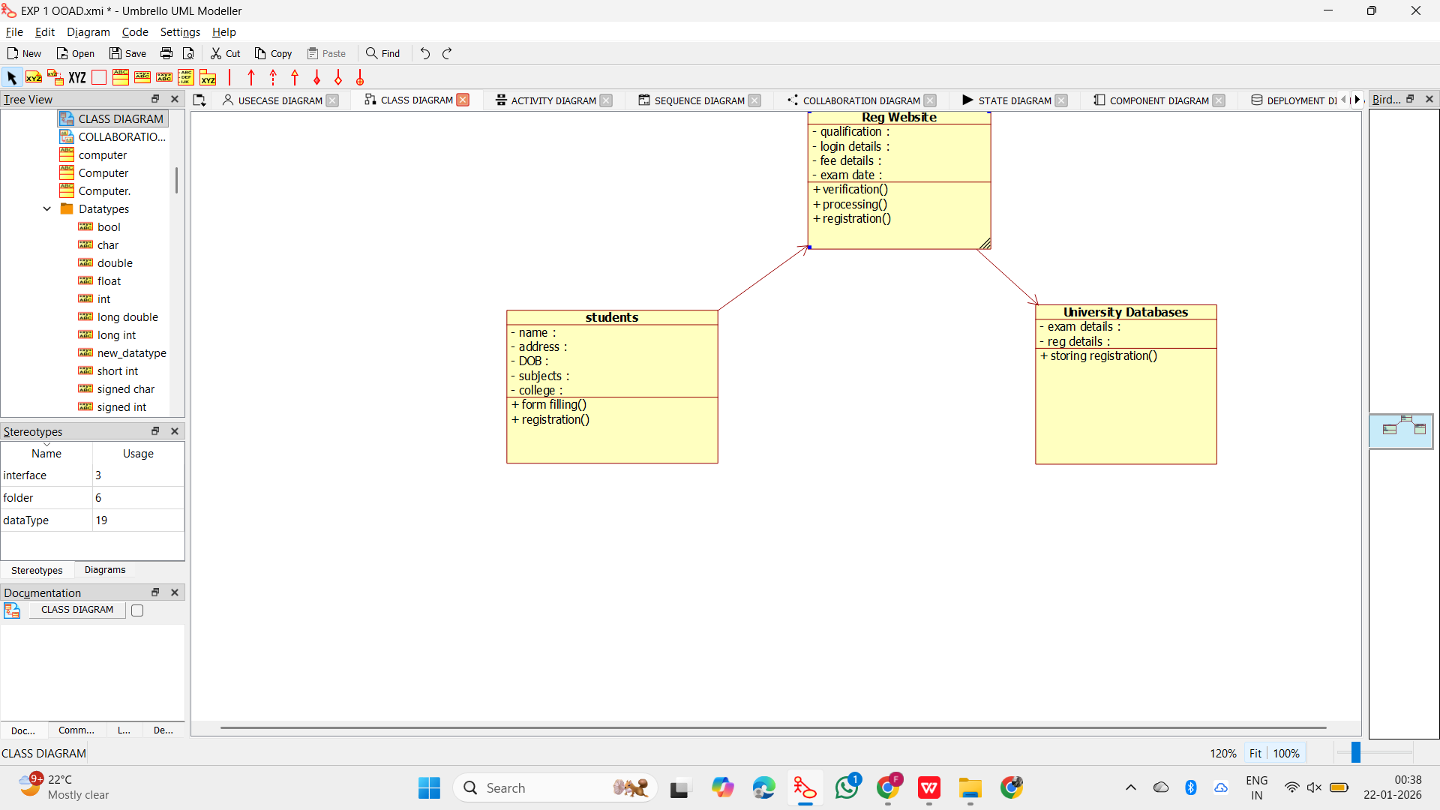

3.ACTIVITY DIAGRAM:

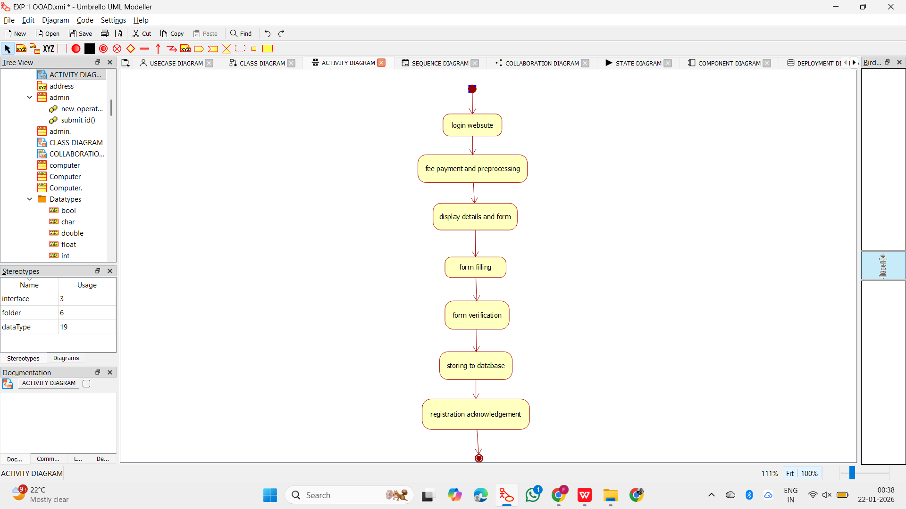

4.SEQUENCE DIAGRAM:
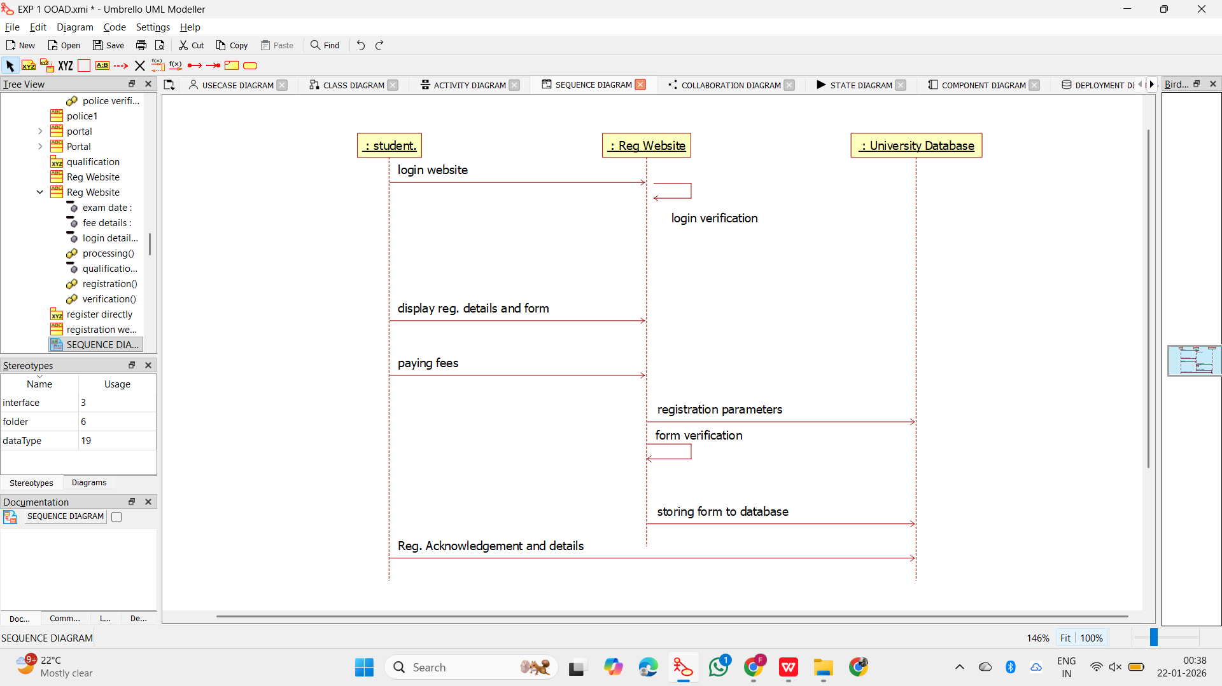

5.COLLABORATION DIAGRAM:

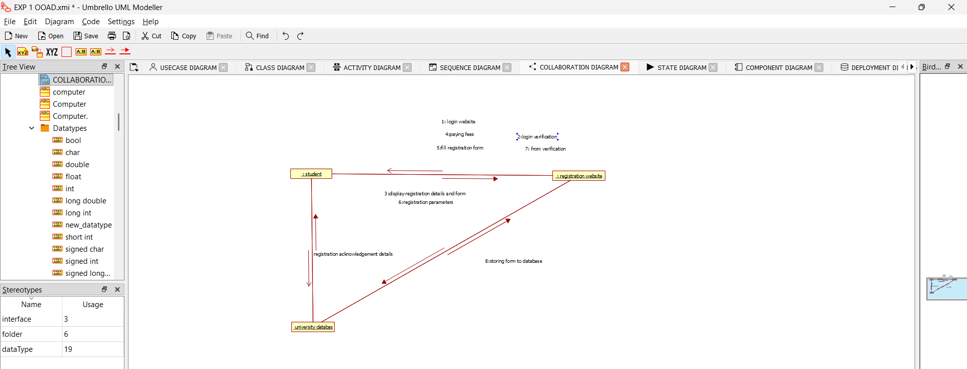

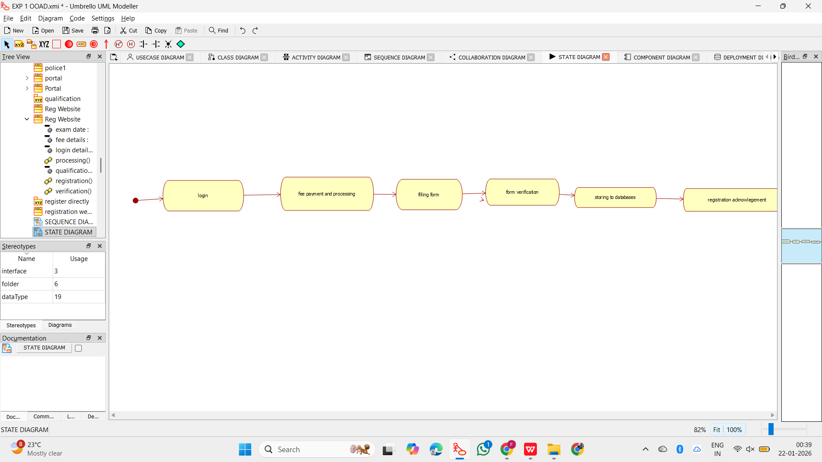
6.STATE DIAGRAM:

7.COMPONENT DIAGRAM:

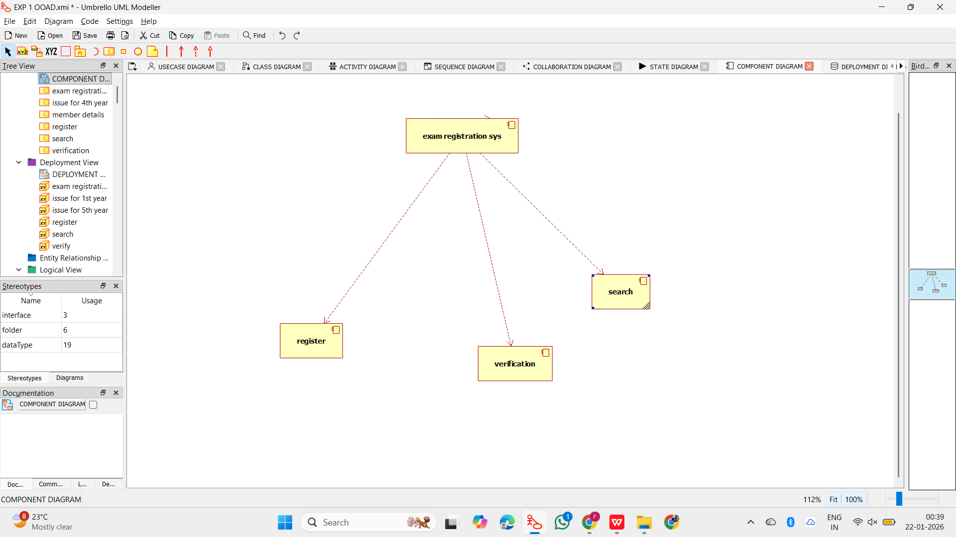

8.DEPLOYMENT DIAGRAM:

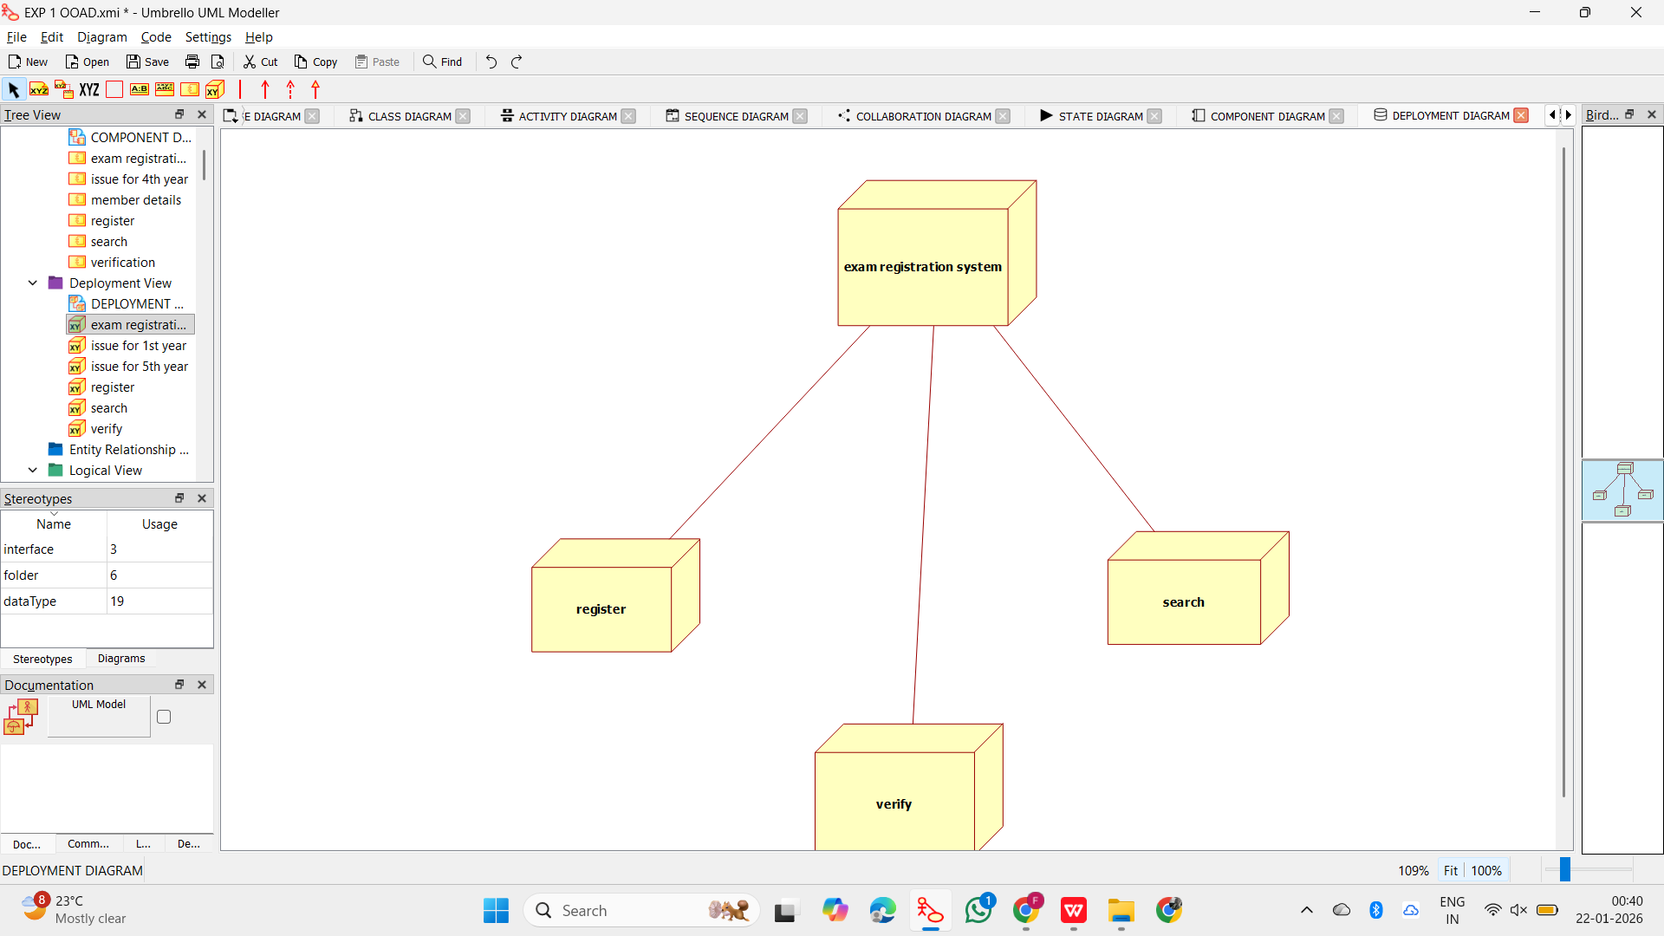

9.PACKAGE DIAGRAM:

